UNITED STATES DISTRICT COURT FOR THE WESTERN DISTRICT OF NORTH CAROLINA

Select a division DIVISION

|  |  |  |
| --- | --- | --- |
| UNITED STATES OF AMERICA  v.  Click or tap here to enter text. | )  )  )  )  )  )  ) | DOCKET NO. Click or tap here to enter text.  WRIT OF HABEAS CORPUS AD PROSEQUENDUM |

TO:

TO:

TO:

The Director, Bureau of Prisons, Washington, D.C.

U.S. Marshals, Western District of North Carolina,

Enter detention facility **and address OR** NCDAC)

**IT IS ORDERED** that you have the body of Enter text, Offender#, RACE, Birth Year YYYY, detained in your facility, under safe and secure conduct, brought before the Honorable Select Judge, United States Magistrate Judge, Western District of North Carolina, in the City of Enter city., North Carolina, FORTHWITH, for proceedings on or before ______________ at __________, to make an appearance before the Court on charges now pending against the Defendant, as well as any other related federal charges that may be filed.

**IT IS FURTHER ORDERED** that the United States Marshals Service shall return the defendant to the Enter detention facility **OR** NCDAC), under safe and secure conduct, after the disposition of the above-captioned case as well as any other related federal charges that may be filed against the Defendant.

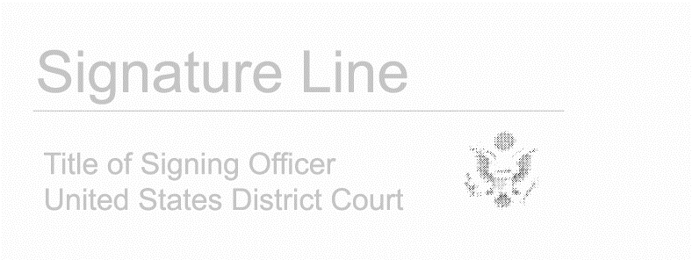**SO ORDERED.**