AO 442 (Rev. 11/11) Arrest Warrant – NCWD 8/3/2026
United States District Court
for the
Western District of North Carolina
United States of America |  |  |  |  |  |  |  |  | )  )  )  )  )  )
v. |  |  |  |  |  |  |  |  | )  )  )  )  )  )
 |  |  |  |  |  |  |  |  | )  )  )  )  )  ) | Case No.
Defendant

ARREST WARRANT
To: Any authorized law enforcement officer
YOU ARE COMMANDED to arrest and bring before a United States magistrate judge without unnecessary delay
(name of person to be arrested)
who is accused of an offense or violation based on the following document filed with the court:
☐ | Indictment | ☐ | Superseding Indictment |  |  |  | ☐ | Information |  |  |  | ☐ | Superseding Information |  |  | ☐ | Complaint
☐ | Probation Violation Petition |  |  |  | ☐ | Supervised Release Violation Petition |  |  |  |  |  |  |  | ☐ | Violation Notice | ☐ | Order of the Court
This offense is briefly described as follows:
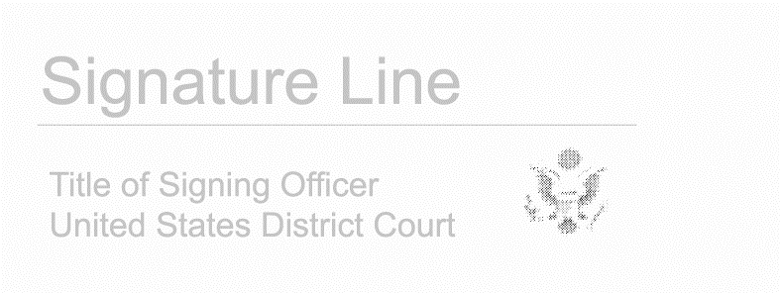
Date and time issued:

 |  |  |  |  |  |  |  |  |  | Issuing Officer’s signature
City and state: |  |  |  |  |  |  |  |  | Choose an item.
 |  |  |  |  |  |  |  |  | Printed name and title
Return
 |  | This warrant was received on (date) |  |  |  |  |  | , and the person was arrested on (date)
At (city and state)
Date:
 |  |  |  |  |  |  |  |  |  | Arresting Officer’s signature
 |  |  |  |  |  |  |  |  |  | Printed name and title

AO 442 (Rev. 11/11) Arrest Warrant – NCWD 8/3/2026 (Page 2)
This second page contains personal identifiers provided for law-enforcement use only
and therefore should not be filed in court with the executed warrant unless under seal.
(Not for Public Disclosure)
Name of defendant/offender:
Known aliases:
Last known residence:
Prior addresses to which defendant/offender may still have ties:
Last known employment:
Last known telephone numbers:
Place of birth:
Date of birth:
Social Security number:
Height: |  |  |  |  |  |  |  |  |  |  |  | Weight:
Sex: |  |  |  |  |  |  |  |  |  |  |  | Race:
Hair: |  |  |  |  |  |  |  |  |  |  |  | Eyes:
Scars, tattoos, other distinguishing marks:
History of violence, weapons, drug use:
Known family, friends, and other associates (name, relation, address, phone number):
FBI number:
Complete description of auto:
Investigative agency and address:
Name and telephone numbers (office and cell) of pretrial services or probation officer (if applicable):
Date of last contact with pretrial services or probation officer (if applicable):

