AO 109 (Rev. 11/13) Warrant to Seize Property Subject to Forfeiture – NCWD – 5/26
United States District Court
for the
Western District of North Carolina
In the Matter of the Seizure of |  |  |  |  |  |  |  | )  )  )  )  )
(Briefly describe the property to be seized)
 |  |  |  |  |  |  |  |  |  | Case No.
WARRANT TO SEIZE PROPERTY SUBJECT TO FORFEITURE
To: Any authorized law enforcement officer
An application by a federal law enforcement officer or an attorney for the government requests that certain property
 | be seized as being subject to forfeiture to the United States of America. The property is described as follows:
I find that the affidavit(s) and any recorded testimony establish probable cause to seize the property.
YOU ARE COMMANDED to execute this warrant and seize the property on or before
 |  |  |  |  |  |  |  |  |  |  |  | (not to exceed 14 days)
 |  | ☐ | in the daytime 6:00 a.m. to 10:00 p.m. |  |  | ☐ | at any time in the day or night because good cause has been established.
Unless delayed notice is authorized below, you must also give a copy of the warrant and a receipt for the property taken to the person from whom, or from whose premises, the property was taken, or leave the copy and receipt at the place where the property was taken.
An officer present during the execution of the warrant must prepare, as required by law, an inventory of any property seized and the officer executing the warrant must promptly return this warrant and a copy of the inventory to
 |  |  |  |  |  |  |  |  | .
(United States Magistrate Judge)
 |  | ☐ | Pursuant to 18 U.S.C. § 3103a(b), I find that immediate notification may have an adverse result listed in 18 U.S.C.
§ 2705 (except for delay of trial), and authorize the officer executing this warrant to delay notice to the person who, or whose
property, will be searched or seized (check the appropriate box)
 |  | ☐ | for |  | days (not to exceed 30) | ☐ | until, the facts justifying, the later specific date of |  |  |  |  |  |  | .

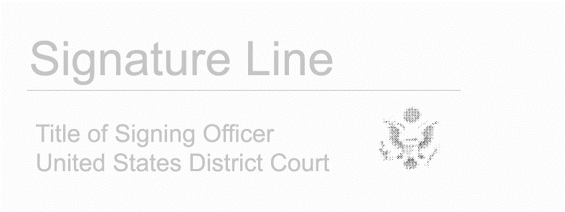

Date and time issued: |  | Click or tap to enter a date. |  | Judge’s signature
City and state: |  |  |  | Choose an item.
 |  |  |  | Printed name and title

AO 109 (Rev. 11/13) Warrant to Seize Property Subject to Forfeiture (Page 2)

Return
Case No.: |  | Date and time warrant executed: |  | Copy of warrant and inventory left with:
Inventory made in the presence of:
Inventory of the property taken:
Certification
I declare under penalty of perjury that this inventory is correct and was returned along with the original warrant to the designated judge.
Date:
 |  |  | Executing officer’s signature
 |  |  | Printed name and title

