AO 106A (08/18) Application for a Warrant by Telephone or Other Reliable Electronic Means – NCWD 5/26
United States District Court
for the
Western District of North Carolina
In the Matter of the Search of |  |  |  |  |  |  |  |  |  |  |  | )  )  )  )  )  )
(Briefly describe the property to be searched  or identify the person by name and address) |  |  |  |  |  |  |  |  |  |  |  | )  )  )  )  )  )
 |  |  |  |  |  |  |  |  |  |  |  | )  )  )  )  )  ) | Case No.
APPLICATION FOR A WARRANT BY TELEPHONE OR OTHER RELIABLE ELECTRONIC MEANS
I, a federal law enforcement officer or an attorney for the government, request a search warrant and state under penalty of perjury that I have reason to believe that on the following person or property (identify the person or describe the property to be searched and give its location):
located in the |  |  |  |  |  |  |  |  | District of |  |  |  |  | , there is now concealed (identify the
person or describe the property to be seized):
The basis for the search under Fed. R. Crim. P. 41(c) is (check one or more):
 |  |  | ☐ |  | evidence of a crime;
 |  |  | ☐ |  | contraband, fruits of crime, or other items illegally possessed;
 |  |  | ☐ |  | property designed for use, intended for use, or used in committing a crime;
 |  |  | ☐ |  | a person to be arrested or a person who is unlawfully restrained.
The search is related to a violation of:
Code Section |  |  |  |  |  |  |  |  | Offense Description
The application is based on these facts:
 | ☐ | Continued on the attached sheet.
 | ☐ | Delayed notice of |  |  |  |  |  |  | days (give exact ending date if more than 30 days: |  |  |  |  |  | ) is requested
 |  | under 18 U.S.C. § 3103a, the basis of which is set forth on the attached sheet.
 |  |  |  |  |  |  |  |  |  |  |  | Applicant’s signature
 |  |  |  |  |  |  |  |  |  |  |  | Printed name and title
Attested to by the applicant in accordance with the requirements of Fed. R. Crim. P. 4.1 by
 |  |  |  |  |  |  | (specify reliable electronic means).
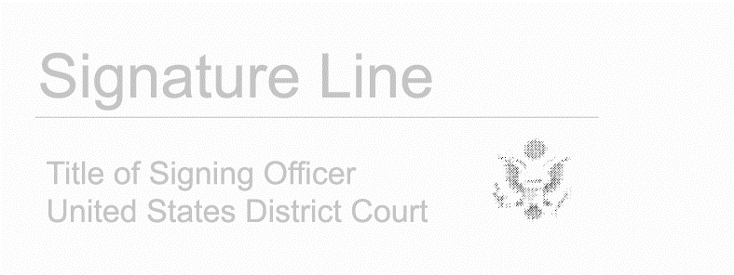

Date:
City and state: |  |  | Judge’s signature

