AO 104 Rule 4.1(Rev. 07/16) Tracking Warrant – NCWD – 5/26
United States District Court
for the
Western District of North Carolina
In the Matter of the Tracking of  (Identify the person, property, or object to be tracked ) |  |  |  |  |  |  |  |  |  |  |  |  |  |  | )  )  )  )  )  )
 |  |  |  |  |  |  |  |  |  |  |  |  |  |  |  |  |  |  |  |  | Case No.
Rule 4.1 -TRACKING WARRANT
To: Any authorized law enforcement officer
An application by a federal law enforcement officer or an attorney for the government shows there is reason to believe that the person, property, or object described above has been involved in and likely will continue to be involved in the criminal
activity identified in the application, and |  |  |  |  |  |  |  |  |  | ☐ |  |  | is located in this district; |  |  |  |  |  |  |  |  | ☐ | is not now located in this district, but will be at
execution; |  |  |  | ☐ |  | the activity in this district relates to domestic or international terrorism; |  |  |  |  |  |  |  |  |  |  |  |  |  |  |  |  |  |  | ☐ | other:
I find that the affidavit(s), and any recorded testimony, establish probable cause to believe that
(check the appropriate box) |  |  |  |  |  |  |  | ☐ | using the object |  |  |  |  |  |  |  | ☐ |  | installing and using a tracking device
to monitor the location of the person, property, or object will satisfy the purpose set out in Fed. R. Crim. P. 41(c) for issuing a warrant.
 | ☐ |  | I find entry into the following vehicle or onto the following private property to be necessary without approval or
knowledge of the owner, custodian, or user of the vehicle or property for installing, maintaining, and removing the tracking device:
YOU ARE COMMANDED to execute this warrant and begin use of the object or complete any installation authorized
by the warrant by |  |  |  |  |  |  |  |  |  |  |  |  |  |  |  |  | (no later than 10 days from the date this warrant was issued) and may continue to use the
device until |  |  |  |  |  |  |  |  |  |  |  |  |  | (no later than 45 days from the date this warrant was issued). The tracking may occur
within this district or another district. To install, maintain, or remove the device, you may enter (check boxes as appropriate)
☐ | into the vehicle described above |  |  |  |  |  |  |  |  |  |  | ☐ |  |  |  | onto the private property described above
☐ | in the daytime 6:00 a.m. to 10:00 p.m. |  |  |  |  |  |  |  |  |  |  | ☐ |  |  |  | at any time in the day or night because good cause has been established.
Within 10 calendar days after the use of the tracking device has ended, the officer executing this warrant must both
return it to (United States Magistrate Judge) |  |  |  |  |  |  |  |  |  |  |  |  |  |  |  |  |  |  |  |  |  |  |  |  |  |  | and — unless delayed notice
is authorized below — serve a copy of the warrant on the person who, or whose property or object, was tracked.
 | ☐ |  | Pursuant to 18 U.S.C. § 3103a(b)(1), I find that immediate notification may have an adverse result listed in 18 U.S.C.
§ 2705 (except for delay of trial), and this warrant prohibits the seizure of any tangible property or any wire or electronic communications (as defined in 18 U.S.C § 2510). I therefore authorize the officer executing this warrant to delay notice to the person who, or whose property or object, will be tracked (check the appropriate box)
 | ☐ |  | for |  |  |  |  | days (not to exceed 30) |  |  |  |  |  | ☐ |  |  |  | until, the facts justifying, the later specific date of |  |  |  |  |  |  |  |  |  |  |  |  | .
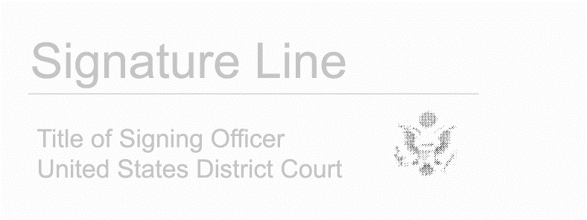
Sworn in accordance with Rule 4.1.
Date and time issued
 |  |  |  |  |  |  |  |  |  |  |  |  |  |  |  |  |  |  |  | Judge’s signature
City and state:
AO 104 (Rev. 07/16) Tracking Warrant (Page 2)
Case No.
Return of Tracking Warrant With Installation
1. Date and time tracking device installed:
2. Dates and times tracking device maintained:
3. Date and time tracking device removed:
4. The tracking device was used from (date and time):
to (date and time): |  |  |  |  |  |  |  |  |  |  |  |  |  |  |  |  |  |  |  |  |  |  |  |  |  |  |  |  | .
Return of Tracking Warrant Without Installation
1. Date warrant executed:
2. The tracking information was obtained from (date and time):
to (date and time): |  |  |  |  |  |  |  |  |  |  |  |  |  |  |  |  |  |  |  |  |  |  |  |  |  |  |  |  | .
Certification
I declare under the penalty of perjury that this return is correct and was returned along with the original warrant to the designated judge.
Date: |  | Click or tap to enter a date.
 |  |  |  |  |  |  |  |  |  |  |  |  |  |  |  |  |  |  |  | Executing officer’s signature
 |  |  |  |  |  |  |  |  |  |  |  |  |  |  |  |  |  |  |  | Printed name and title

