AO 102 (01/09) Application for a Tracking Warrant – NCWD 5/26
United States District Court
for the
Western District of North Carolina
In the Matter of the Tracking of  (Identify the person to be tracked or describe  the object or property to be used for tracking) |  |  |  |  |  |  |  |  |  | )  )  )  )  )  )
 |  |  |  |  |  |  |  |  |  | )  )  )  )  )  ) | Case No.
APPLICATION FOR A TRACKING WARRANT
I, a federal law enforcement officer or attorney for the government, have reason to believe that the person, property, or object described above has been and likely will continue to be involved in one or more violations of
 |  |  | U.S.C. § |  |  |  |  | . Therefore, in furtherance of a criminal investigation, I request authority to install and
use a tracking device or use the tracking capabilities of the property or object described above to determine location. The application is based on the facts set forth on the attached sheet.
 |  | ☐ |  | The person, property, or object is located in this district. |  |  |  |  |  |  | ☐ | The activity in this district relates to domestic or  international terrorism.
 |  | ☐ |  | The person, property, or object is not now located  in this district, but will be at the time of execution. |  |  |  |  |  |  | ☐ | Other:
The tracking will likely reveal these bases for the warrant under Fed. R. Crim. P. 41(c): (check one or more)
 |  | ☐ |  | evidence of a crime; |  |  |  |  |  |  | ☐ | contraband, fruits of crime, or other items illegally  possessed;
 |  | ☐ |  | property designed for use, intended for use, or used  in committing a crime; |  |  |  |  |  |  | ☐ | a person to be arrested or a person who is  unlawfully restrained.
☐ | I further request, for purposes of installing, maintaining or removing the tracking device, authority to enter the  following vehicle or private property, or both:
☐ | Delayed notice of |  |  |  |  |  | days (give exact ending date if more than 30 days: |  |  |  |  |  |  |  | ) is requested under
 | 18 U.S.C. § 3103a, the basis of which is set forth on the attached sheet.
 |  |  |  |  |  |  |  |  |  |  | Applicant’s signature
 |  |  |  |  |  |  |  |  |  |  | Applicant’s printed name and title
Sworn to before me and signed in my presence.
 |  |  |  |  |  |  |  |  |  |  | 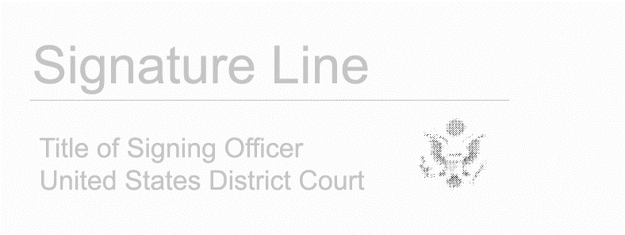
Date:
 |  |  |  |  |  |  |  |  |  |  | Judge’s signature
City and state:

