AO 93A (Rev. 11/13) Search and Seizure Warrant on Oral Testimony – NCWD 6/24
United States District Court
for the
Western District of North Carolina
In the Matter of the Search of |  |  |  |  |  |  |  |  |  |  | )  )  )  )  )
(Briefly describe the property to be searched
or identify the person by name and address)
 |  |  |  |  |  |  |  |  |  |  |  |  | Case No.
SEARCH AND SEIZURE WARRANT ON ORAL TESTIMONY
To: Any authorized law enforcement officer
I have received, and recorded electronically or by handwriting, sworn testimony communicated to me by
(name the officer) |  |  |  |  |  |  |  |  |  |  |  |  |  |  |  |  | , who requests the search of
the following person or property located in the |  |  |  |  |  |  |  |  | Western |  |  |  |  | District of |  | North Carolina
(identify the person or describe the property to be searched and give its location):
I am satisfied that circumstances make it reasonable to dispense with a written affidavit and that the testimony establishes probable cause to search and seize the person or property, described above, and that such search will reveal
(identify the person or describe the property to be seized):
YOU ARE COMMANDED to execute this warrant on or before |  |  |  |  |  |  |  |  |  |  |  |  |  |  |  |  |  |  | (not to exceed 14 days)
 | ☐ | in the daytime 6:00 a.m. to 10:00 p.m. |  |  |  |  |  | ☐ |  | at any time in the day or night because good cause has been established.
Unless delayed notice is authorized below, you must give a copy of the warrant and a receipt for the property taken to the person from whom, or from whose premises, the property was taken, or leave the copy and receipt at the place where the property was taken.
The officer executing this warrant, or an officer present during the execution of the warrant, must prepare an inventory
as required by law and promptly return this warrant and inventory to |  |  |  |  |  |  |  |  |  |  |  |  |  |  |  |  |  |  |  | .
 |  |  |  |  |  |  |  |  |  |  |  |  | (United States Magistrate Judge)
 | ☐ | Pursuant to 18 U.S.C. § 3103a(b), I find that immediate notification may have an adverse result listed in 18 U.S.C.
§ 2705 (except for delay of trial), and authorize the officer executing this warrant to delay notice to the person who, or whose
property, will be searched or seized (check the appropriate box)
 | ☐ | for |  |  | days (not to exceed 30). |  | ☐ |  | until, the facts justifying, the later specific date of |  |  |  |  |  |  |  |  | enter date |  | .
 |  |  |  |  |  |  |  |  |  |  |  | 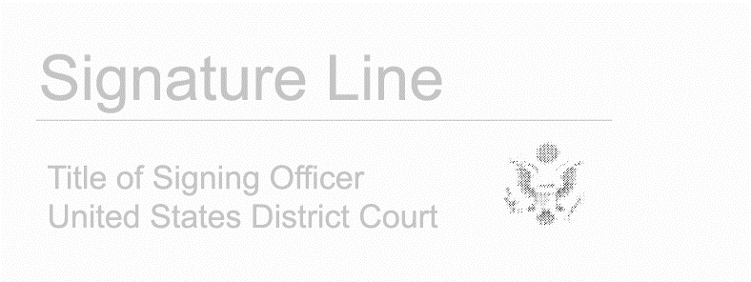
Date and time issued: |  |  |  |  |  | enter date
 |  |  |  |  |  |  |  |  |  |  |  | Judge’s signature
City and state: |  |  |  |  |  |  |  |  |  |  |  | Choose an item.
 |  |  |  |  |  |  |  |  |  |  |  | Printed name and title
I certify that the judge named above authorized me to sign his or her name.
Applicant’s printed name |  |  |  |  |  |  |  |  |  |  |  | Applicant’s signature

AO 93A (Rev. 11/13) Search and Seizure Warrant on Oral Testimony (Page 2)
Return
Case No.: |  | Date and time warrant executed: |  | Copy of warrant and inventory left with:
Inventory made in the presence of :
Inventory of the property taken and name of person(s) seized:
Certification
I declare under penalty of perjury that this inventory is correct and was returned along with the original warrant to the designated judge.
Date: | enter date
 |  |  | Executing officer’s signature
 |  |  | Printed name and title

