AO 108 (Rev. 06/09) Application for a Warrant to Seize Property Subject to Forfeiture
United States District Court
for the
Western District of North Carolina
In the Matter of the Seizure of |  |  |  |  | )  )  )  )  )
(Briefly describe the property to be seized)
 |  |  |  |  |  |  | Case No.
RULE 4.1 - APPLICATION FOR A WARRANT
TO SEIZE PROPERTY SUBJECT TO FORFEITURE
I, a federal law enforcement officer or attorney for the government, request a seizure warrant and state under
penalty of perjury that I have reason to believe that the following property in the |  |  |  |  |  |  |  |  |  | District of
 |  |  |  | is subject to forfeiture to the United States of America under |  |  |  |  |  |  | U.S.C. §
 |  |  | (describe the property):
The application is based on these facts:
 | ☐ | Continued on the attached sheet.
 |  |  |  |  |  | Applicant’s signature
 |  |  |  |  |  | Printed name and title
Sworn in accordance with Rule 4.1.
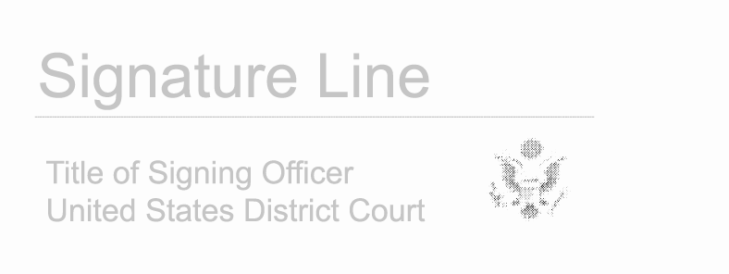

Date: enter date
Judge’s signature
City and state:
Printed name and title

