AO 91_Rule 4.1 (Rev. 11/11) Criminal Complaint – NCWD – 5/26
United States District Court
for the
Western District of North Carolina
United States of America |  |  |  |  |  |  |  |  |  | )  )  )  )  )  )  )
v.
 |  |  |  |  |  |  |  |  |  |  |  | Case No.
Defendant(s)
RULE 4.1 - CRIMINAL COMPLAINT
I, the complainant in this case, state that the following is true to the best of my knowledge and belief.
On or about the date(s) of |  |  |  | enter date |  |  |  |  |  |  | in the county of |  |  |  | in the
 |  |  | District of |  |  |  |  |  | , the defendant(s) violated:
Code Section |  |  |  |  |  |  | Offense Description
This criminal complaint is based on these facts:
 | ☐ | Continued on the attached sheet.
 |  |  |  |  |  |  |  |  |  |  |  | Complainant’s signature
 |  |  |  |  |  |  |  |  |  |  |  | Printed name and title
Sworn in accordance with Rule 4.1.
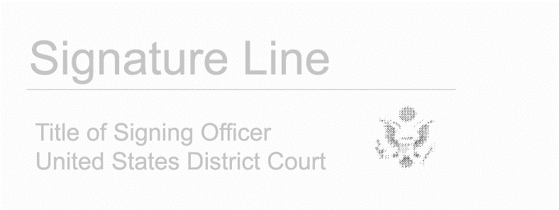

Date: enter date
 |  |  | Judge’s signature
City and state: |  |  | Choose an item.
 |  |  | Printed name and title

