AO 106 (Rev. 04/10) Application for a Search Warrant
United States District Court
for the
Western District of North Carolina
In the Matter of the Search of |  |  |  |  |  |  |  |  |  | )  )  )  )  )  )
(Briefly describe the property to be searched
or identify the person by name and address)
 |  |  |  |  |  |  |  |  |  |  |  | Case No.
APPLICATION FOR A SEARCH WARRANT
I, a federal law enforcement officer or an attorney for the government, request a search warrant and state under penalty of perjury that I have reason to believe that on the following person or property (identify the person or describe the property to be searched and give its location):
located in the |  |  |  |  |  |  |  | District of |  |  |  |  | , there is now concealed (identify the
person or describe the property to be seized):
The basis for the search under Fed. R. Crim. P. 41(c) is (check one or more):
 |  |  | ☐ |  | evidence of a crime;
 |  |  | ☐ |  | contraband, fruits of crime, or other items illegally possessed;
 |  |  | ☐ |  | property designed for use, intended for use, or used in committing a crime;
 |  |  | ☐ |  | a person to be arrested or a person who is unlawfully restrained.
The search is related to a violation of:
Code Section |  |  |  |  |  |  |  | Offense Description
The application is based on these facts:
 | ☐ | Continued on the attached sheet.
 | ☐ | Delayed notice of |  |  |  |  |  | days (give exact ending date if more than 30 days: |  |  |  |  |  |  | ) is requested
 |  | under 18 U.S.C. § 3103a, the basis of which is set forth on the attached sheet.
 |  |  |  |  |  |  |  |  |  |  | Applicant’s signature
 |  |  |  |  |  |  |  |  |  |  | Printed name and title
Sworn to before me and signed in my presence.
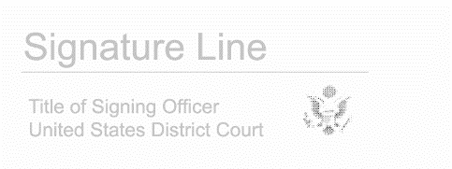

Date: enter date
Judge’s signature
City and state:
Printed name and title

